

**WEB APP DEVELOPMENT**

**BSCS-4**

**Lab 9**

Name: Eshal Siraj

SAP ID: 54686

Submitted to: Mam Nayab Khalid

**TASK 1 and 2:**

Before toggling to dark mode and mouse hovered over button:

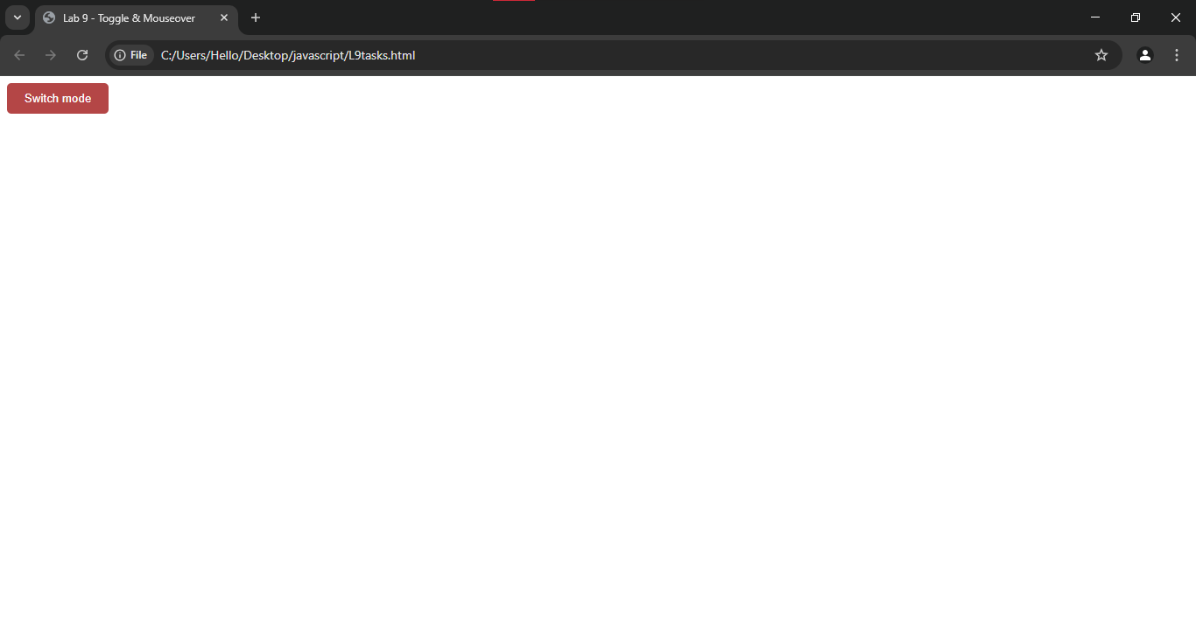

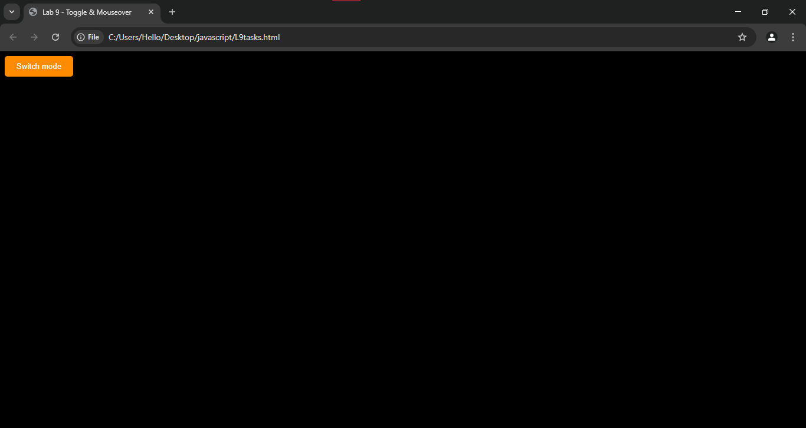After hovering over and clicking the button: